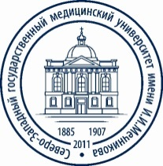

The Federal State Budgetary Educational Institution of Higher Education
“North-Western State Medical University named after I. I. Mechnikov” of the Ministry of Health of the Russian Federation

Information
for foreign citizens applying to M.D. course in General Medicine (31.05.01), partly in English
on the basis of the contract for the provision of paid educational services

Application deadline
from September, 14 to October, 16, 2020

Statement of consent to enrollment deadline
till October, 27, 2020

Entrance examination dates
Subject | Chemistry | Biology
Main day | October, 20  10:00 | October, 22  10:00
Backup day | October, 21  10:00 | October, 23  10:00

Pre-examination schedule
Chemistry | Biology
October, 19  11:00 | October, 19  13:00

